**Phase 1 – GanttProject**

**Factory Method Pattern**

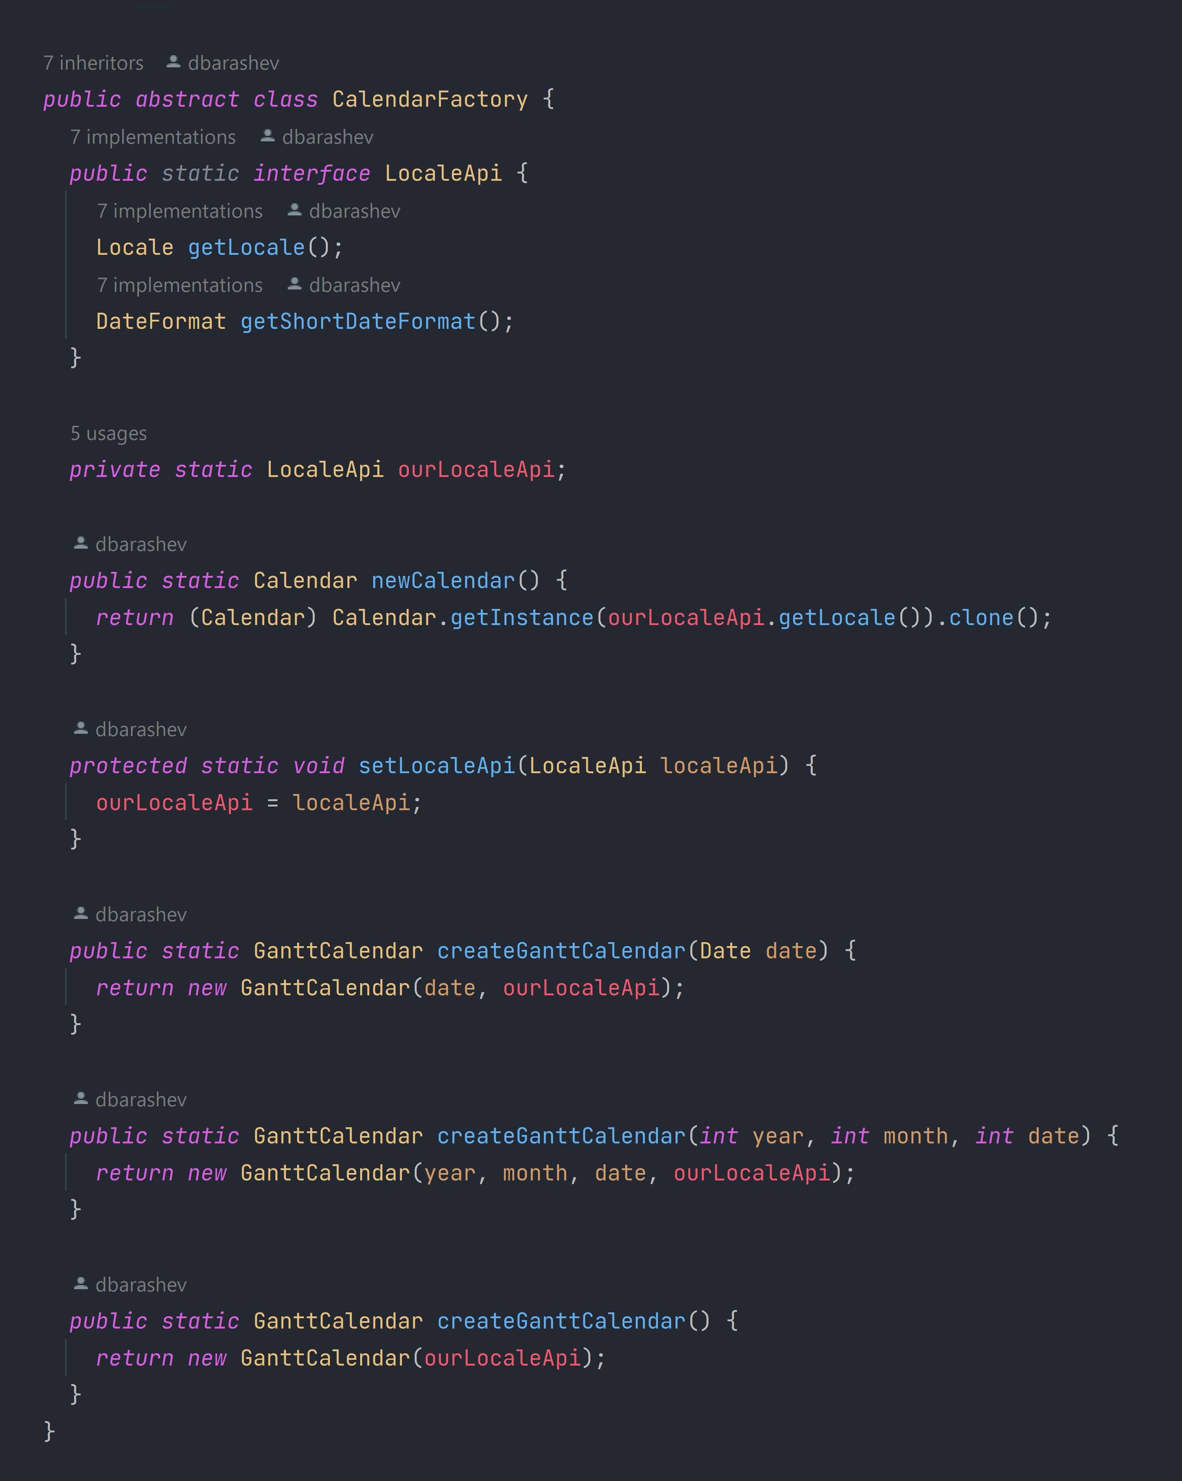

biz.ganttproject.core.time.CalendarFactory

This is a Factory Method design pattern because it hides the creation of instances of the class GanttCalendar behind a factory class CalendarFactory.

* **Product Object:** GanttCalendar

The object type varies depending on the *Locale,* insteadof having subclasses.

The way to specify the product object type here is by setting the *Locale* (via the setLocaleApi method).

* **Factory Object:** CalendarFactory
* **Factory Method:** createGanttCalendar

It’s a static method, so that, even though CalendarFactory isn’t a singleton, the methods may be called directly from the factory object.

**Adapter Pattern**

net.sourceforge.ganttproject.task.event.TaskListenerAdapter

This is an Adapter design pattern because it facilitates the adaptation of the handling of events of different types to the client.

* **Adapter class:** TaskListenerAdapter
* **Target interface:** TaskListener

net.sourceforge.ganttproject.task.event.TaskListener

A client class that uses this adapter class to adapt the handling of events is TaskManagerImpl.

net.sourceforge.ganttproject.task.TaskManagerImpl

**Decorator Pattern**

net.sourceforge.ganttproject.search.SearchService

net.sourceforge.ganttproject.search.SearchServiceBase

This is a Decorator design pattern because we have decorator classes, all with the same common type SearchService, that add their own behavior to a wrapped object.

* **Component interface:** SearchService
* **Base object:** SearchServiceBase
* **Decorators:** TaskSearchService and ResourceSearchService

ResourceSearchService

net.sourceforge.ganttproject.search.TaskSearchService